**Workflow Management System for Ascentic Pvt Ltd.**

**Introduction**

This is a simple application developed for demonstration purposes only. This WMS have two user roles.

1. Manager
2. Executive

Manager can create and assign tasks for executives. Manager also can edit and delete tasks. There are 3 main statuses within the workflow process (To Do, In Progress, Done, Delayed). Each status has its own view to display tasks that are in above mentioned statuses. This application doesn’t use any authentication mechanism. I have implemented a hard coded login feature for demo purposes. Following are the credentials.

[manager@some.com](mailto:manager@some.com) – manager@123

[exec1@some.com](mailto:exec1@some.com) – exec1@123

[exec2@some.com](mailto:exec2@some.com) – exec2@123

**Main Features**

1. Manager can create, edit and delete tasks.
2. Manager can assign tasks to executives.
3. Executives can start progress and complete tasks.
4. Follows up on tasks that are reaching deadlines. (Enables a reminder 1 day before the deadline)
5. Follows up on delayed tasks.
6. Display tasks with regards to multiple workflow statuses(To Do, In Progress, Done, Delayed)
7. Display task count in each status.
8. Provide a Web API and MVC frontend separately.

**Technologies and Tools Used**

1. ASP.NET Web API 2
2. Entity Framework 6. Code First.
3. ASP.NET MVC 5.
4. SQL Server 2017, Visual Studio 2015.

**Architecture Diagram**

* Web API project is developed using a multi-layer architecture with repository pattern.
* MVC client application use factory design pattern to create HTTP connections.

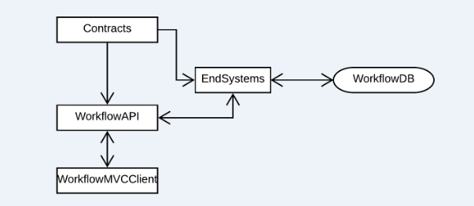

**Thank you!**